Git & Git Hub
To check if git is already installed and is of which version.
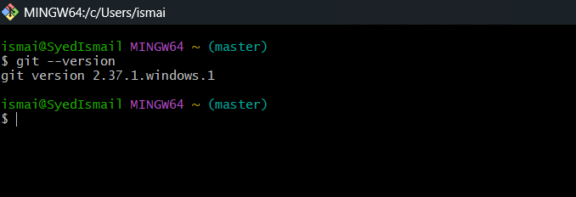

To initialize and create a new empty directory with .git extension
git init

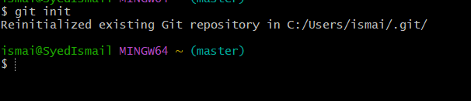

To check the changes in the directory we use command
git status
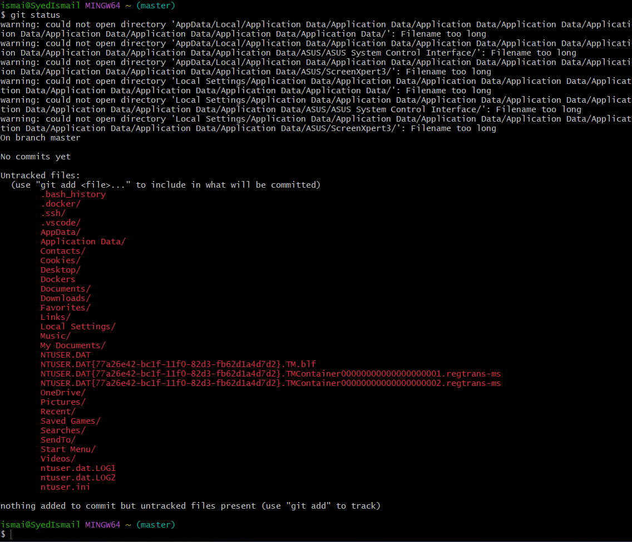

To list the initialized files, we use ls -a command
